

  
  
FOOD DRIVE

benefiting

families in Carrollton, Farmers Branch, Addison, Coppell  
 & city of Dallas in Denton County

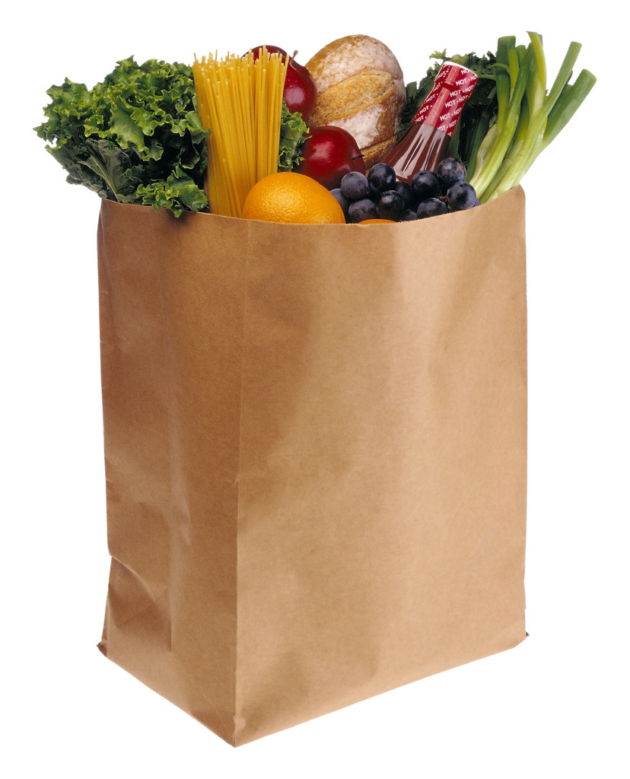

Help feed

LOCAL

families

Drop off your food donations by: _December 31st

2048 E. Hebron Parkway, Carrollton, Texas 75007

972-385-0500 www.sonomahouseal.com